THE MARTIAN

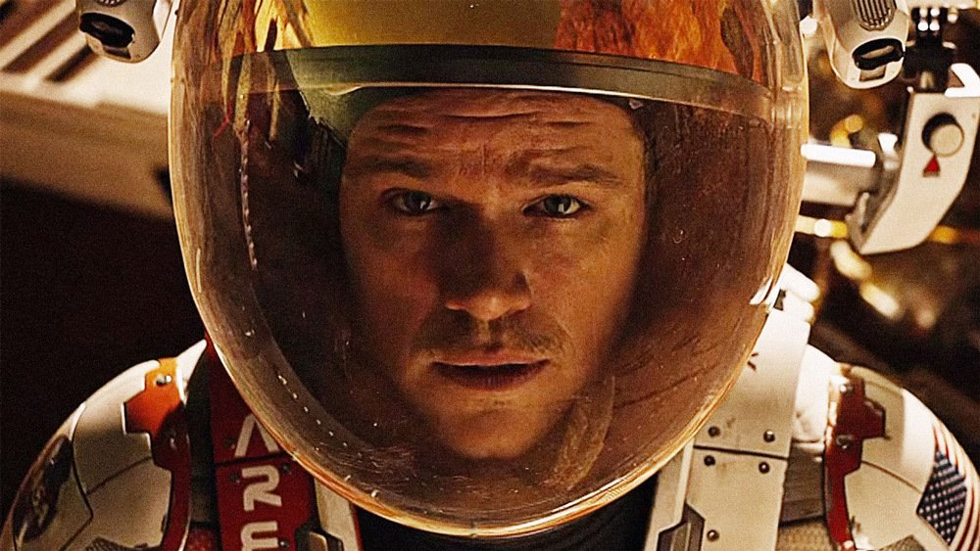

The Martian is about an astronaut Mark Watney (Damon). After only 18 sols (a sol is a day in Martian-speak), this NASA botanist has been left for dead on the Red Planet. His crew, including Michael Peña, Kate Mara, Aksel Hennie and Sebastian Stan, all under the command of a Jessica Chastain, believe he died in a dust storm, his spacesuit and torso punctured by a flying antenna. So they abort the mission and head back to Earth, where Watney is mourned as a martyr.
Cue the complications. Satellite photos reveal that Watney is still alive, using botany ingenuity to survive. He even grows potatoes — you’ll never guess whose manure he uses as fertilizer. But how is he going to “science the shit out of” his plight and stay alive for the four years it’ll take to land a rescue mission (he has enough food for only a month)? You do the math. Actually, you don’t have to, since the NASA director (Jeff Daniels), his Mars expert (Chiwetel Ejiofor) and their harried PR guru (Kristen Wiig, of all people) are back home sweating out a solution. Will the original crew members, still in transit to Earth, risk their lives on a rescue mission? I’ll put it this way: The space program hasn’t had a propaganda boost this effective since Apollo 13. As he was in Saving Private Ryan, Damon is again a symbol of the American determination to leave no man behind.

GHOST IN THE SHELL

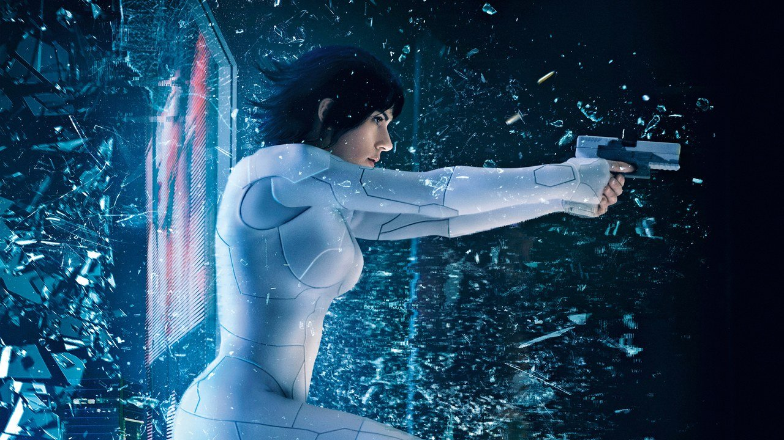

“Ghost in the Shell” is full of dazzling images that suggest a rich, profound narrative the film is never able to achieve. A young woman brutally rips the hatch off a tank. Her skin and bones crack, revealing mechanical sinew underneath her human exterior. Holographic advertisements the size of skyscrapers glitter across the city’s landscape. Surgeons wear uniforms the colour of fresh blood. A robot fashioned in the form of a geisha bends her appendages, crawling up the wall like a frightened spider. These visual delights may provoke momentary awe but they have little impact.
Director Rupert Sanders and his collaborators aren’t recreating the influential manga or its 1995 anime adaptation wholesale. This isn’t inherently a problem. But how they choose to change this material is. They take the basic skeleton of the story and some its tantalizing imagery, but strip them of their power.
It is hard to ignore when you notice how the most important characters are white or that every time Aramaki speaks Japanese the Major only replies in English. “Ghost in the Shell” makes the troubling decision to use Japanese culture, visual flourishes, and source material but decides that a Japanese actress as the lead would be a step too far. At times, “Ghost in the Shell” is beautiful, even stunning. But these visual pleasures can’t mask the narrative emptiness. Never has there been a film so obsessed with the human soul that proves soulless itself.

ALITA: BATTLE ANGEL

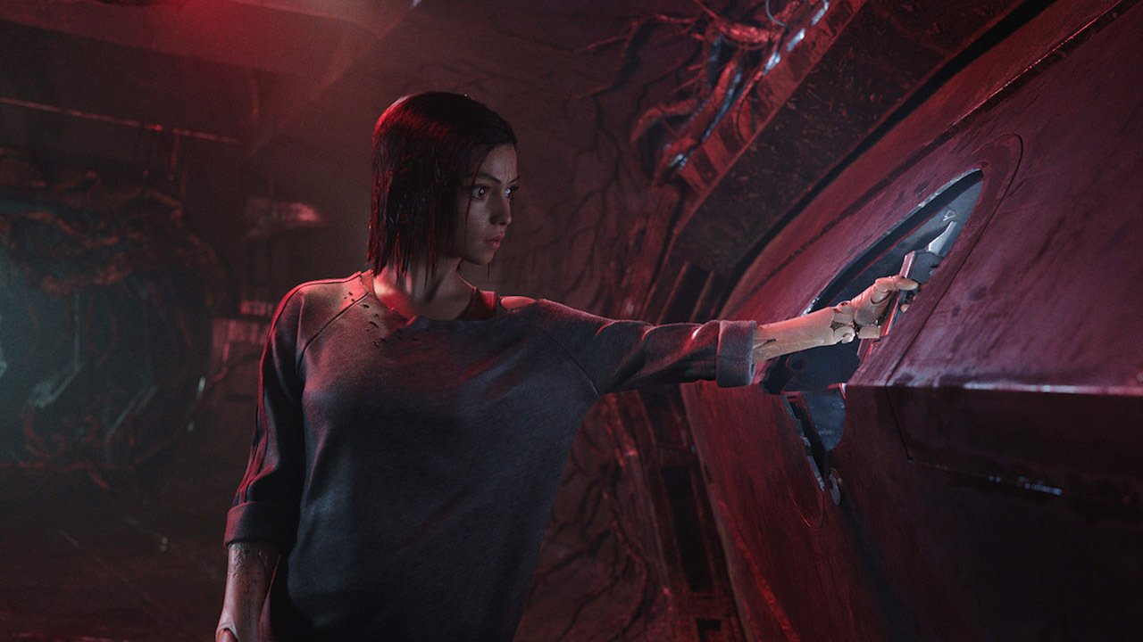

As far as movies about girl robots go, “Alita” isn’t so bad. The movie’s star is a promising Rosa Salazar as the namesake hero, a mysterious yet powerful teen girl bot with oversized anime-style eyes and a good and very powerful heart that could power a city. Alita is the last of her kind, a superior enemy who was somehow were defeated by the humans. After she was found in a scrap heap, Alita is brought back to life with the help of a fatherly doctor, Dr. Ido (Christoph Waltz), a paternal relationship that gives “Alita” some of its more stranger moments. More straightforward is the relationship Alita has with a secret nemesis, Chiren (Jennifer Connelly), Dr. Ido’s former wife, and Vector (Mahershala Ali), a smooth-talking kingpin who promises almost anyone who will listen to him a ticket to Zalem, the city hovering in the sky holding society’s upper class over the heads of the poor below. far as movies about girl robots go, “Alita” isn’t so bad.
The movie’s star is a promising Rosa Salazar as the namesake hero, a mysterious yet powerful teen girl bot with oversized anime-style eyes and a good and very powerful heart that could power a city. Alita is the last of her kind, a superior enemy who was somehow were defeated by the humans. After she was found in a scrap heap, Alita is brought back to life with the help of a fatherly doctor, Dr. Ido (Christoph Waltz), a paternal relationship that gives “Alita” some of its more stranger moments.

ROBOCOP

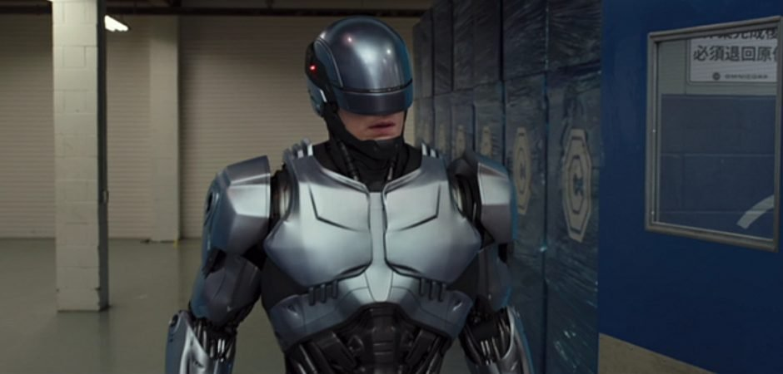

Stepping into Peter Weller's shoes, Joel Kinnaman provides the fleshy body parts, which are duly encased within a cybernetic suit – a cynical ploy to get round regulations outlawing robot "weapons" on American soil. Presented as little more than a disembodied assortment of head, lungs and hand (some very effective special effects), Murphy becomes a latterday Tin Man – the song from The Wizard of Oz is a recurrent taunt – his limbs hacked away, still dreaming of a human heart.
But does Murphy have "free will" or have his emotions been overridden by medicine and machines? Can he still be a father and husband, a head-bashing Him to the forthcoming Her?
Modern anxieties about deadly war drones and automated domestic responses are efficiently mined, while Michael Keaton and Gary Oldman (both graduates of the various Batman film franchises) make the most of their respective roles as slimy corporate exec and horribly compromised scientist.

THE MAZE RUNNER

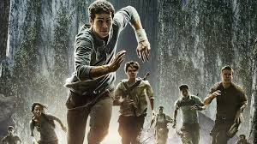

Thomas (Dylan O’Brien), a teenager, arrives in a glade at the centre of a giant labyrinth. Like the other youths dumped there before him, he has nomemory of his previous lfe. Thomas quickly becomes part of the group and soon after demonstrates a unique perspective that scores him a promotion to Runner status (those who patrol the always changing maze tofind an escape route). Together with Teresa (Kaya Scodelario),the only female, Thomas tries to convince his cohorts that knows a way out.
It’s all stylishly shot by debutant director Wes Ball, who snatches spare moments between scares and action scenes to give a sense of the Glade environment or build a character like Thomas Brodie Sangster’s Newt or Blake Cooper’s Chuck. But in the second half, things fall apart as the action picks up; the puzzle-solving element to the maze is played well, but the monsters, once they finally appear, are a sometimes unconvincing cross between The Host’s slimy river monster and a Wild Wild West-style robot spider. They are effectively terrifying though, with a sting that induces a sort of psychosis to add to their fearsome armour of machine parts and sharp teeth, and there is a surprisingly high body count as the pace builds towards the end.
Worst of all, the film can only offer an unsatisfactory conclusion to the mystery at its own heart. That means Thomas and Teresa, in particular, can never progress beyond blandly heroic cyphers, because their characters remain opaque, even to themselves. Like Divergent earlier this year, the full explanation for the premise is a vital plot point in a sequel, so the riddle at the heart of this maze only leads to more riddles.

THE MAZE RUNNER: THE SCORCH TRIAL

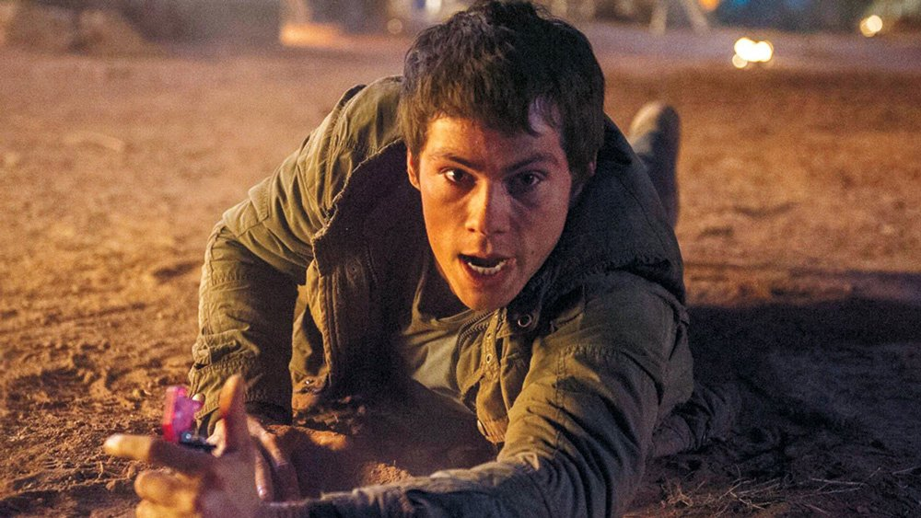
I feel that The Scorch Trials didn’t have as much going for it as the first book; it started off really well and then there were parts where it’s just them walking through the desert and commenting on the heat and the wind. It could get a bit uninteresting at moments but then there are moments that are so thrilling that they have you on the edge of your seat and your heart beating fast desperate to know what might happen next!
I think there are a few things that James Dashner adds to the story and some of the characters that are really clever and you don’t see them coming. It gives you a bit more insight into WICKED and what they are doing and I really liked that. It just gives you a bit more to think about which is really good as I like mentally challenging books that make you think a lot.
There are some new characters introduced who I really liked and I thought it was good to add characters with different back stories and experiences from the Gladers. They remember more about what was going on and it was interesting getting to know them.
I really liked the concept of the scorch and how it is just miles and miles of desert wasteland. One of the reasons I liked it was because it’s all based on nature; anything dangerous that happens is usually caused by nature and so it wasn’t as though the Gladers could fight off any monsters because everything that’s happening is kind of natural. It’s interesting seeing the Gladers challenged in that way and seeing how they behave in different situations. It’s just a bit more thrilling because anybody can suddenly become ill from the heat or not enough food and you literally have no idea when it might happen – whereas in The Maze Runner anything bad that happens is through the grievers.
THE MAZE RUNNER:THE DEATH CURE

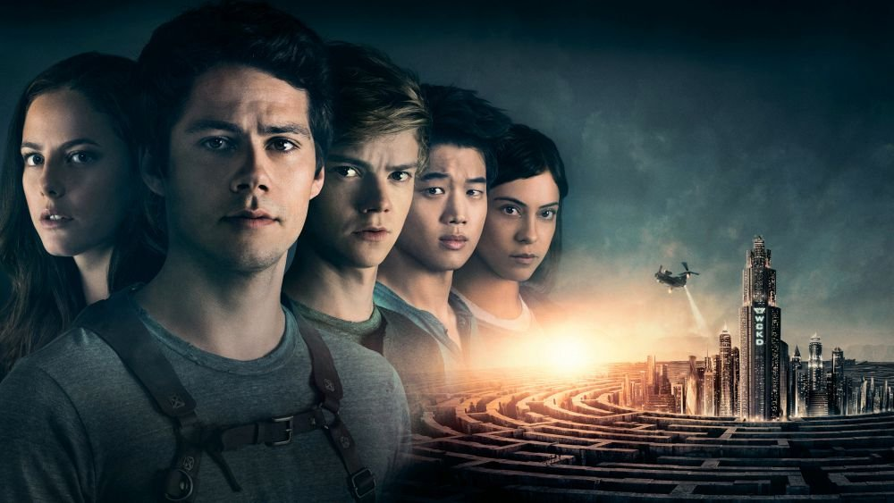

“The Death Cure” picks up soon after “The Scorch Trials.” The aforementioned train rescue saves a large group of children held captive by WICKED, which harvests the young seeking a cure for the zombie virus, but it fails to retrieve Minho (Ki Hong Lee), Thomas’s buddy since the maze. And Thomas (Dylan O’Brien), as ever, won’t leave anyone behind.
Poor Brenda (Rosa Salazar) persists in appearing to pine for Thomas, but he still carries the torch for the traitorous Teresa (Kaya Scodelario), now an assistant to the WICKED’S chief Machiavellian (Patricia Clarkson). Thomas reserves most of his emotion for Newt (Thomas Brodie-Sangster), whose immunity to the virus comes into question, prompting an outpouring.
Gally (Will Poulter), resurrected with an almost comical lack of fanfare, is the only character with a sense of humour. Still, it’s hard to accuse a movie with a rescue by airborne bus of excessive self-seriousness.

AVATAR

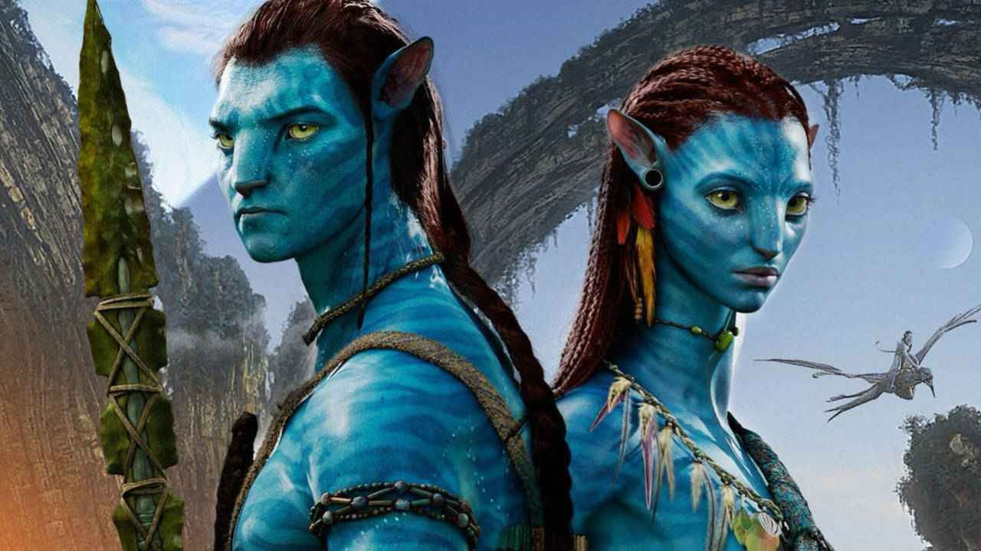
The story, set in the year 2154, involves a mission by U. S. Armed Forces to an earth-sized moon in orbit around a massive star. This new world, Pandora, is a rich source of a mineral Earth desperately needs. Pandora represents not even a remote threat to Earth, but we nevertheless send in ex-military mercenaries to attack and conquer them. Gung-ho warriors employ machine guns and pilot armored hover ships on bombing runs. You are free to find this an allegory about contemporary politics. Cameron obviously does.
Pandora harbors a planetary forest inhabited peacefully by the Na'vi, a blue-skinned, golden-eyed race of slender giants, each one perhaps 12 feet tall. The atmosphere is not breathable by humans, and the landscape makes us pygmies. To venture out of our landing craft, we use avatars--Na'vi lookalikes grown organically and mind-controlled by humans who remain wired up in a trance-like state on the ship. While acting as avatars, they see, fear, taste and feel like Na'vi, and have all the same physical adeptness.
This last quality is liberating for the hero, Jake Sully (Sam Worthington), who is a paraplegic. He's been recruited because he's a genetic match for a dead identical twin, who an expensive avatar was created for. In avatar state he can walk again, and as his payment for this duty he will be given a very expensive operation to restore movement to his legs. In theory he's in no danger, because if his avatar is destroyed, his human form remains untouched. In theory.
On Pandora, Jake begins as a good soldier and then goes native after his life is saved by the lithe and brave Neytiri (Zoe Saldana). He finds it is indeed true, as the aggressive Col. Miles Quaritch (Stephen Lang) briefed them, that nearly every species of life here wants him for lunch. (Avatars are not be made of Na'vi flesh, but try explaining that to a charging 30-ton rhino with a snout like a hammerhead shark).
The Na'vi survive on this planet by knowing it well, living in harmony with nature, and being wise about the creatures they share with. In this and countless other ways they resemble Native Americans. Like them, they tame another species to carry them around--not horses, but graceful flying dragon-like creatures. The scene involving Jake capturing and taming one of these great beasts is one of the film's greats sequences.

DIVERGENT

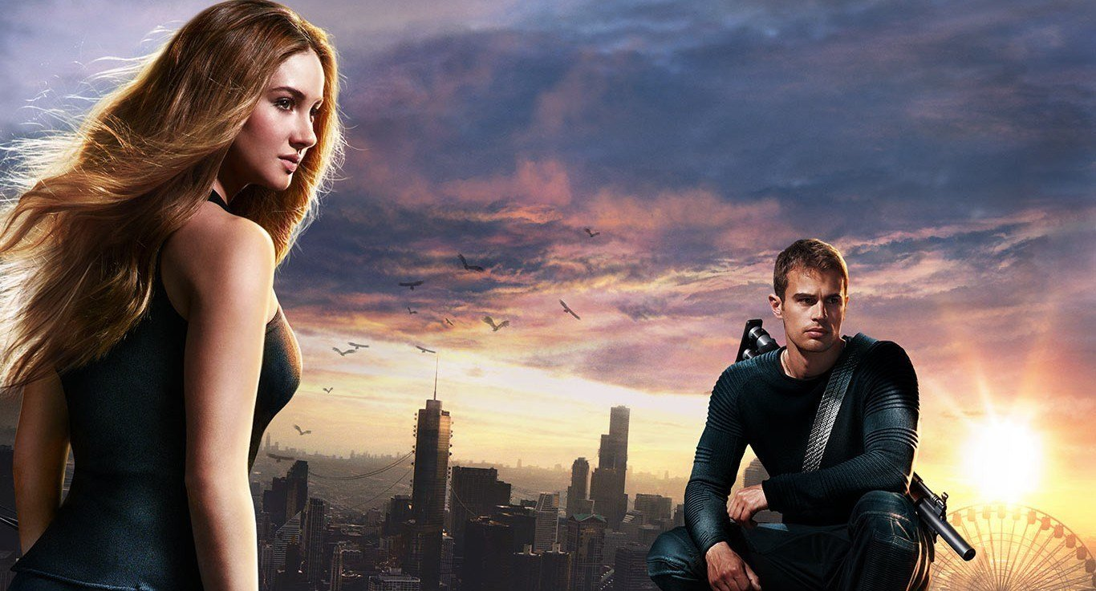
Divergent is a story about a dystopian future where everyone is divided into factions. If you are kind you belong with Amity. If you are honest you belong with Candor. If you value intelligence you belong to Erudite. If you are selfless you are Abnegation and if you are brave then you are Dauntless.
Each year the sixteen-year-olds of the city take a test which tells them which of the five factions they conform to. After the test they will attend the Choosing Ceremony, where they get to decide which faction they want to belong to.
Beatrice Prior is one of these sixteen year olds. Beatrice is an Abnegation-raised girl, who grew up with her brother Caleb, her mother and her father, who is a city leader. But the test is something that Beatrice is dreading because she doesn’t know if she can spend the rest of her life being selfless.
When the day of the test comes around Beatrice is told that she does not conform to any one faction, but to three: Erudite, Abnegation and Dauntless. This makes Beatrice a Divergent and also a threat.
The next day, when Beatrice and her family attend the Choosing Ceremony things take another unexpected turn. Caleb joins Erudite and Beatrice chooses Dauntless.
After jumping onto a train, jumping off a train and then off a building, Beatrice enters the Dauntless compound, where she meets her instructor Four; he asks her for her name, but Beatrice hesitates, then says “Tris”.
Despite brutal Dauntless training and being bullied by her fellow initiates, Tris still finds time to fall in love with Four. But when Erudite threatens to take down Tris’s previous home, her love for Four has to wait. I won’t give any spoilers but I will say what happens is pretty awesome.
It is an amazing story of finding out who you really are and what it is like to fall in love. You cannot fault it.

AFTER EARTH

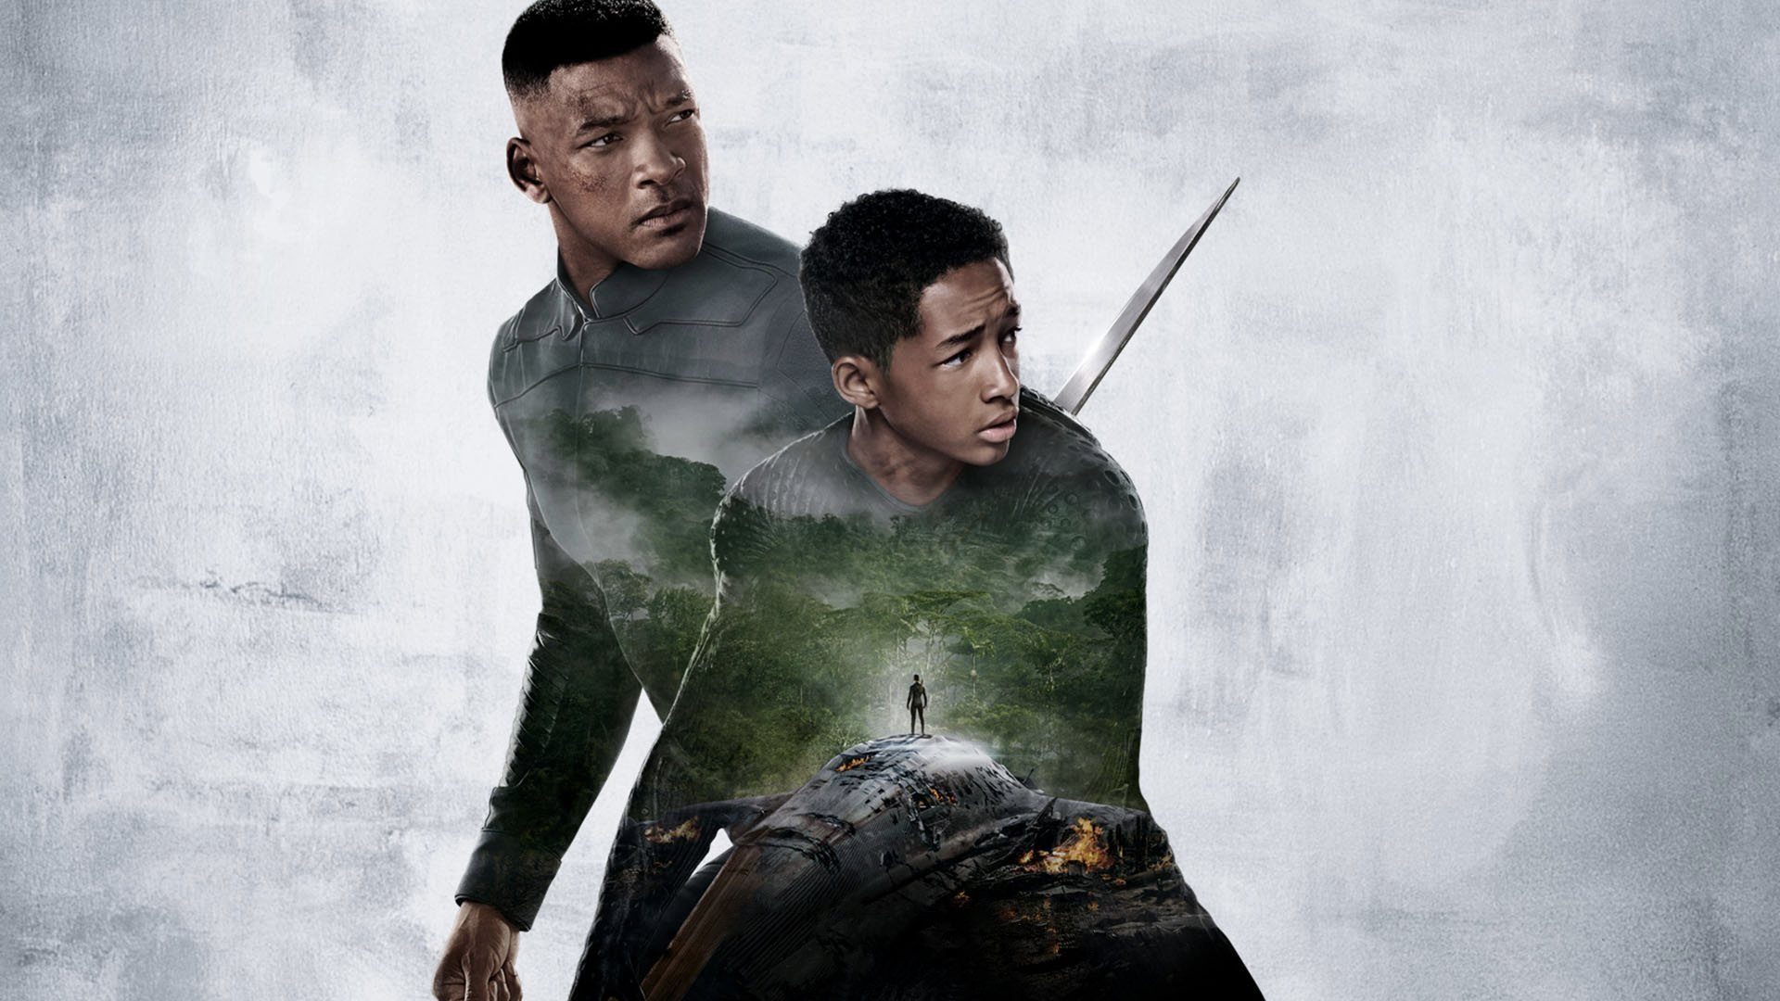
I personally think the movie is good. Yes, it's not great but it is subtly good for a quick watch.
It shows Kitai development as a character where he had to be independent during his time on Earth in order to help his father.
It also shows how one should be brave in facing their fears and this kind of theme certainly piqued my interest as an audience.
But with that aside, it is kind of disappointing that Will Smith doesn't actually do anything other than sitting on the chair and giving instruction to his son. Yes, he was injured but as a fan, we surely want to see him to do something other than that.
Either way, it is a good watch for those who seeks for a simple action slash sci-fi movie.

