TO ALL THE BOYS I LOVED BEFORE

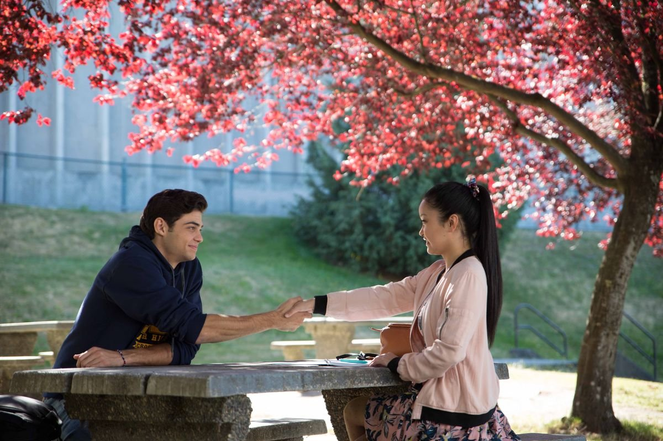

To All the Boys I’ve Loved Before” is based on a best-selling YA novel by Jenny Han, and inspired by her own teen years, when she would write letters to the boys she had crushes on, but never send them. “I write a letter when I have a crush so intense that I don’t know what else to do,” Lara Jean (Lana Condor) tells us.
The letters are more from her to herself than they are to the boys. She keeps them in a special box from her late mother and looks at them often.
The cute premise of this story is that the five letters written by Lara Jean mysteriously get mailed. Han and screenwriter Sofia Alvarez wisely decide to move briskly past that set-up, with only about ten minutes on the excruciating humiliation and no time at all on the mystery of how it happened. (The culprit is instantly obvious despite a half-hearted attempt at a red herring.) The story veers quickly into a conventional but charming high school romantic comedy.

THE FAULT IN OUR STARS

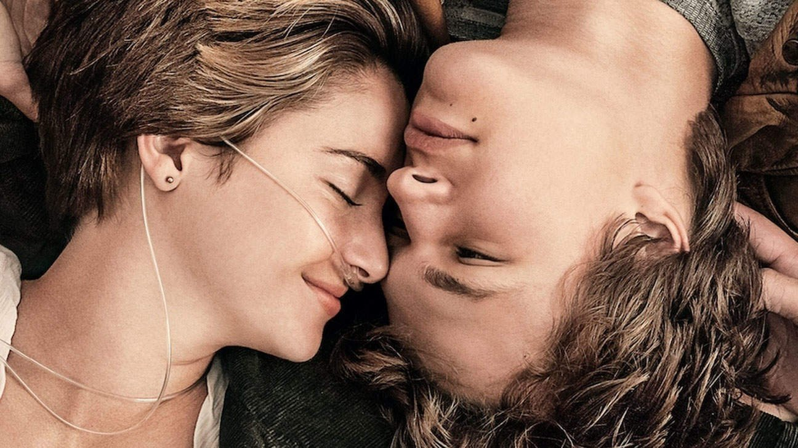

Based on John Green’s bestselling novel, the film offers the first-person accounts of Hazel Grace Lancaster (Woodley), a bright 16-year-old who can hardly remember not living with cancer. She came perilously close to death as a preteen, but an experimental “miracle” treatment beat her disease back to relatively manageable levels: She has to breathe from a tube tethered to an oxygen tank she lugs around like a carry-on bag, and her lifespan has no clear prognosis, but she’s far from helpless.
Her parents (Laura Dern, Sam Trammell) are a loving, lovable pair who worry that Hazel is becoming depressed, as she has no friends and spends her time endlessly rereading reclusive author Peter Van Houten’s postmodern cancer-themed novel, “An Imperial Affliction.” After some insistently gentle prodding, she agrees to attend a weekly church-basement support group hosted by sappy Jesus freak Patrick (Mike Birbiglia).
Here she meets Augustus Waters (Ansel Elgort), a strapping, clever, impossibly handsome 18-year-old whose basketball career was cut short when cancer took his right leg, but who appears to have since made a full recovery. He asks Hazel out on a series of chaste hangout dates, reads her favourite book, stays up until the hours on the phone with her, and ever-so-gradually brings her out of her shell.

FIVE FEET APART

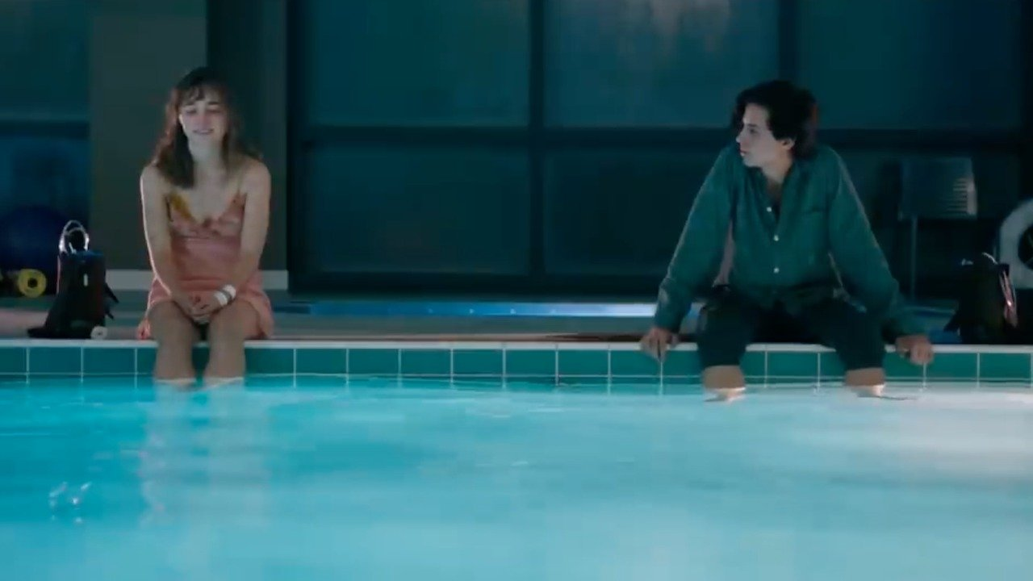

A story about a seventeen-year-old girl named Stella who spends most of her time in the hospital as a cystic fibrosis patient. Her life is full of routines, boundaries and self-control -- all of which get put to the test when she meets Will, an impossibly charming teen who has the same illness. There's an instant flirtation, though restrictions dictate that they must maintain a safe distance between them. As their connection intensifies, so does the temptation to throw the rules out the window and embrace that attraction.
It is tempting to dismiss this story as “sick-lit” but director Justin Baldoni balances the compelling specifics of CF with the larger questions we all face about creating meaning in a world of uncertainty and loss. And he does it with two gifted and appealing young stars, especially Richardson, whose exquisitely expressive face shows us every hope, fear, hesitation, regret, and longing Stella is feeling.

MIDNIGHT SUN

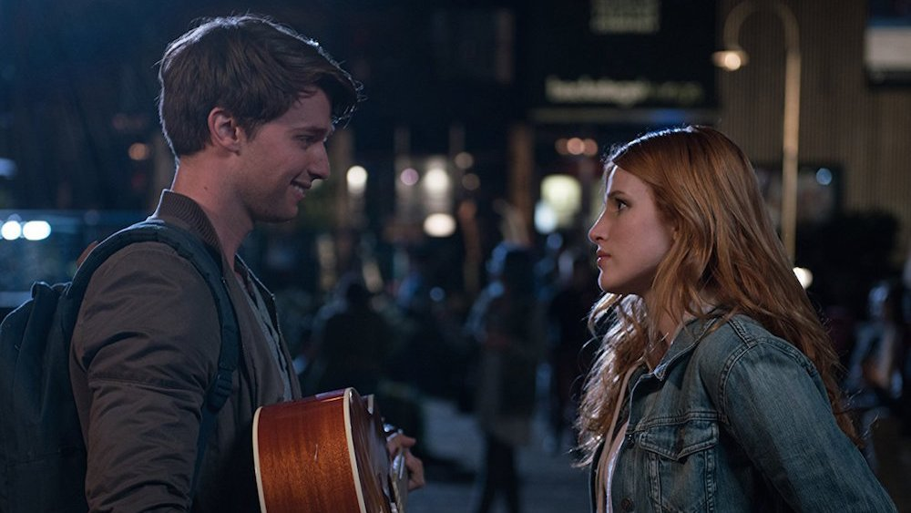

All 17-year-old Katie Price (Bella Thorne) wants is the chance to feel the warmth of the sun on her skin. However, Katie is confined to her home due to a rare genetic condition that makes her highly sensitive to sunlight.
The slightest exposure could kill her. Then she meets and falls in love with Charlie (Patrick Schwarzenegger) who dreams of taking her sailing in the ocean. Who later finds out about the truth about Katie’s sickness.
The movie takes a brilliant point about telling the audience to move on and live life the fullest.

EVERYTHING, EVERYTHING

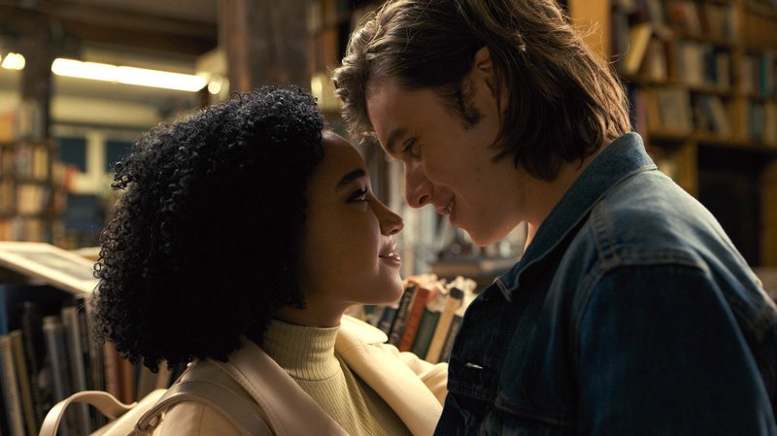

“Everything, Everything,” the latest best-selling young-adult novel to find its way to the big screen, I was content enough to simply bask in the company of 18-year-old Amandla Stenberg and 22-year-old Nick Robinson , the two attractive leads who star as Maddy and Olly in this adolescent romance. Blessed with bright blemish-free faces, a precociously articulate way with words as they discuss calculus and literature, knock-‘em-dead smiles and effusively emotive hair, this pair’s presence puts a welcome sheen on an old thematic chestnut: the destiny-driven infatuation that won’t be denied, even in the face of a potentially lethal disease.
Being around any young people in the throes of a blossoming crush can be a tonic, a contact-high reminder of how it feels to be so consumed by such a rush of intense feelings. It can also be annoying as hell, especially when they shut out the rest of humanity including those who care about them the most. “Everything, Everything” tries to have it both ways and only partially succeeds in being the right romantic medicine.

ME BEFORE YOU

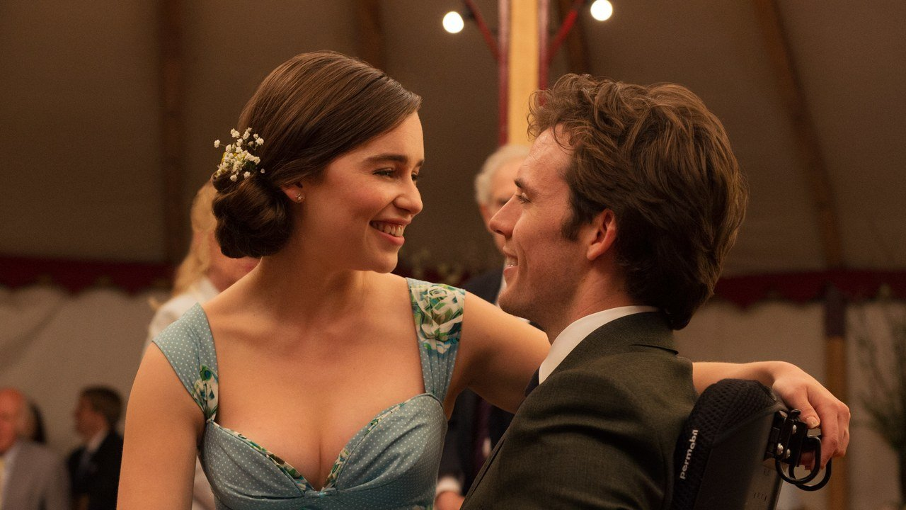

Based on a best-seller by a female author that has been devoured by hordes of female readers, a rich 30-ish man who has shut down his emotions forms a relationship with a fetchingly unsophisticated, younger woman of modest means who is willing to tend to his needs. What starts off as strictly a business proposition eventually grows into a more personal and cozier connection.
I personally think that the movie is very good. It is highly recommended for those who are hopeless romantic. Both actors portray a very good chemistry. You can feel all warm and giddy just by watching them interact after Will had finally become comfortable around Lou.
And the pictures and scenery were amazing too! Everything just portrays warmth and a cozy home-like feeling throughout the movie.
However, I have never wanted a character to live so bad when the movie had finally reached it's ending.
I just somehow wish they would go with a different ending. But of course, that is impossible. I really like how the sad atmosphere that the director trying to portray doesn't feel like a rush or forced into the audience.

THE VOW

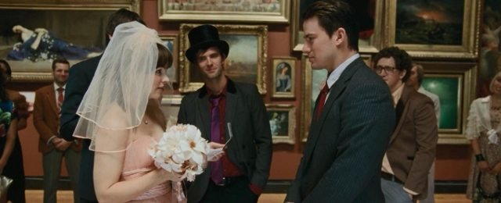

"The Vow" is a well-behaved, tender hearted love story about impossibly nice people. It's not even about whether they'll get married. They've been happily married for four years. The problem is, she can't remember them. She can't even remember her husband.
For me, The Vow has a very predictable story line where the heroine had forgotten about her love one but reconcile back at the end.
However, there is nothing wrong in enjoying a predictable romance once in a while. But, the director never actually displays the sadness or the anguish that the husband nor the wife felt throughout the whole process.
Everything about her wanting a divorce and him trying to make her remember him back just felt like it is being forced into me, the audience.
It's all too painless. One can imagine the anguish of the case in real life.
500 DAYS OF SUMMER

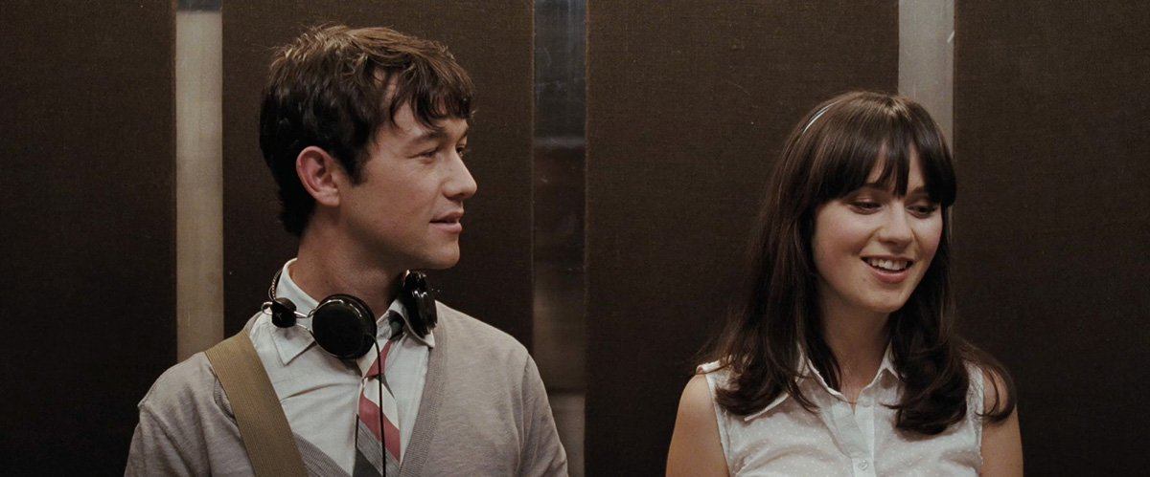

We never remember in chronological order, especially when we’re going back over a failed romance. We start near the end, and then hop around between the times that were good and the times that left pain. People always say “start at the beginning,” but we didn’t know at the time it was the beginning. "500 Days of Summer" is a movie that works that way.
This movie is very, very suitable for those who is having a hard time in getting over their exes.
It portrays that people come into our life for a reason. A reason that we might not realise now but we might realise later.

THE BEST OF ME

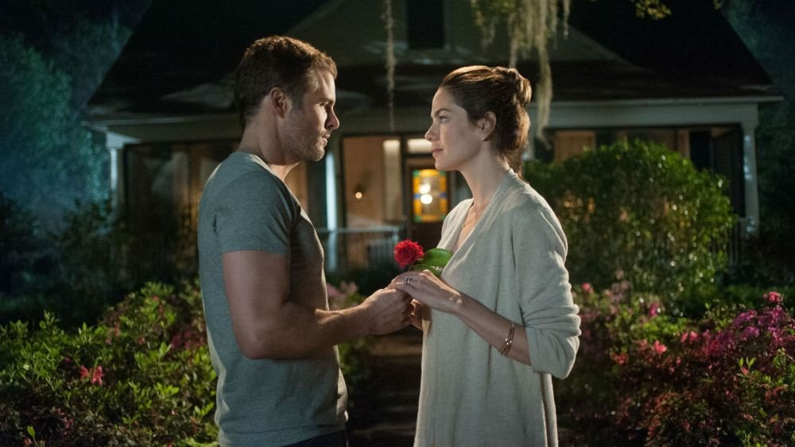

It revolves around a second chance at true love as high-school sweethearts are reunited after 20 years following the death of a mutual friend. The aforementioned hunk is Dawson (James Marsden), a loner of few words who scored 1520 on his SATs yet settled into a blue-collar job.
Amanda (Michelle Monaghan) is an upper-class housewife who dotes on her teen son and bitterly weeps over her crumbling marriage to a self-involved twerp who is an alcoholic and a workaholic. She and Dawson both return to their hometown for the reading of a will of a man named Tuck. Soon they are riffling through the goodies of a fairy-tale cottage they have jointly inherited that is straight out of a Thomas Kincade painting, complete with oaks draped in Spanish moss, fields of rosy posies ripe for the picking and an old-fashioned swimming hole.
At a certain point, though, the coincidences and tragic incidents start to pile up at a startling rate and nothing can be taken seriously. Not that you don’t see these developments coming from miles away.
At a certain point, though, the coincidences and tragic incidents start to pile up at a startling rate and nothing can be taken seriously.

IF I STAY

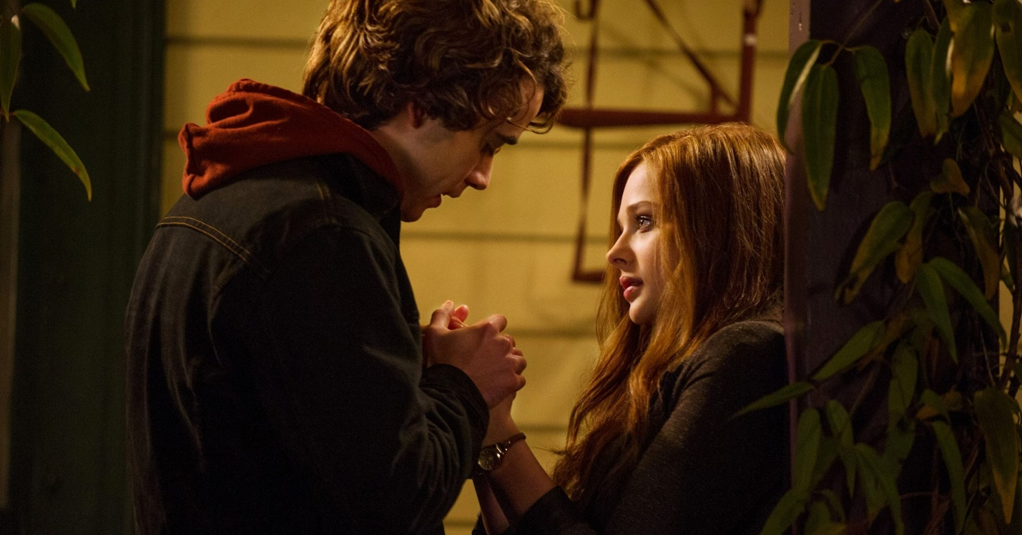

“If I Stay,” based on the weepy young adult novel about a teenage girl trapped in an ethereal realm who must choose between life and death, her grounded, naturalistic presence goes a long way toward making mushy material palatable.
“If I Stay” begins in happier times. Mia, a cello prodigy with dreams of attending Juilliard, is enjoying a snowy morning with her mother and father (Mireille Enos and Joshua Leonard), former rock ‘n’ rollers who’ve toned it down but maintained an irreverent sense of cool, and her younger brother, Teddy (Jakob Davies). Mia will go on to say later in the movie that she feels like a space alien in this family, with her quiet demeanor and love of classical music. But her honest exchanges with her parents—particularly the appealingly down-to-Earth Enos as her mother—are among the film’s strongest moments.
On their way to visit longtime friends and their new baby, the family’s car slams into an out-of-control vehicle on an icy Portland road. As emergency workers dash about treating the victims, Mia finds herself wandering among them in a hazy, out-of-body experience. She quickly hops into her own ambulance to the hospital and continues to follow herself from surgery to the intensive care unit. As her earthly self clings to life, her mind wanders to the past, bringing us up to speed on who she is and how she got here.

